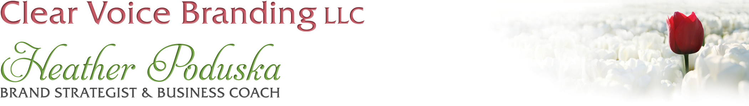
Creating a HOT Freebie!
Your free offerings or opt-ins are the first step in getting clients into your sales funnel. In today’s crowded market, you must demonstrate value before people will buy from you. No matter how great your reputation is, clients will want to get a taste of your personality, expertise and brand before they buy shell out their cash.
Here are some steps to create a hot opt-in that will make people want to sign-up with you:
- What does your audience want more than anything RIGHT NOW?

- What can you offer them that is quick and actionable?

- What can you offer that is repeatable and will get their eyes on your freebie over and over again? A great one for this is check-lists.

- How does you audience like to consume information? Audio, print, video….? (Ask them!)

- What is my visual brand and how can I make this LOOK hot? Canva.com is my fav!

- What is my call to action of up-sell?

- What back-end is needed? Designer, website, Facebook, landing pages, conference line, video camera, email provider etc.

Freebie Brainstorm Session:
Video course
Newsletter
Free PDF or Special Report
Free membership site
Free Facebook group
DVD
Audio download
Free webinar
Free teleseminar
Physical product
Checklists
Quizzes
Books
Recipes
Your top-10 lists
Mistakes for avoid/Favorite tips to try
Videos of talks you’ve done
Old content
Free courses
Printable workbook
A free preview chapter of your book
Your guide to buying something
Your recommended resource list
My Freebie Brainstorm Session

