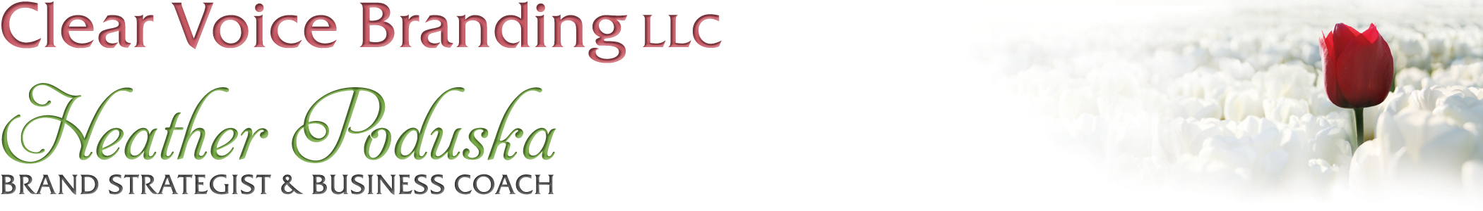
Brand Image Building Blocks

FIT
What is your figure type?
Triangle_______ Rectangle________ Oval_________
Hourglass_____ Figure 8________ Inverted Triangle_________

ABC’s of a good fit
Accentuate-Highlight your best features and assets.
What are your 3 best features?
1.
2.
3.
Balance-A body which looks proportional is visually optimal.
Notice which parts of your body are bigger or smaller in relation to the whole.
What do you need to balance?

Camouflage-Disguise or draw attention away from any trouble areas by using camouflage.
Remember, bright colors draw attention and dark colors make things recede.
What do you want to camouflage?

Tailoring-Very often clothes do not fit us properly right off the rack. Therefore, it is essential to find a good tailor. Go ahead and hem those pants or bring in the waist. Not only will you feel better, your clothes will look more sophisticated and your overall image will be more polished. It is well worth the small investment.

COLOR
Color is one of the very best tools you have to create a pleasing impression with your image. Wearing the right colors for your skin type can make you look younger, healthier, friendlier and even wealthier.
Warm-Warm colors are yellow-based. People with warm coloring tend to look better in creams and browns, peach, yellow, warm greens, fire-engine red etc.
Cool-Cool colors are blue based. People with cool coloring tend to look better in whites, black, greys, pink, blue, cool greens and cherry red etc.
Tips for using color:
-Use darker colors to minimize and lighter colors to accentuate.
-Find accessories in your eye color and wear them near your face. For a man, this could be a tie.
-Please ditch the black (unless you look fabulous in it), especially near your face.
-Generally speaking, the more contrast you have between your hair and skin color, the more contrast you can wear in your color intensity. Conversely, if you have little contrast between your hair and skin color, the softer the contrast of color should be.
-Pay attention to the psychology of color to affect your mood or impact on others.
Here is a list of different psychological associations with color:
Red: power, love, potency, energy, desire, action, passion, determination, courage, confident, stimulating, driven.

Orange: Energy, determination, encouragement, quirky, artistic, vitality, productivity, strength, warmth, the sun, flames.
Blue: Trust, wisdom, truth, loyalty, peace, authority, reliability, loyalty.
Green: growth, nature, rebirth, optimism, spring, fertility, relaxation, youth, healing, luck, environment.
Purple: loyalty, ambition, wealth, competition, mystery, mysticism, spirituality, inspiration, luxury, dignity.
Pink: Love, romance, femininity, calmness, peace, happiness, softness (hot pink) sexiness, energy.
Yellow: Joy, happiness, energy, sunshine, warmth, vision, caution, warning, intellect, creativity, light.

Brown: Wholesome, practical, stable, honest, comforting, earthy, rich, sincere.

Gray: Reliable, conservative, dignified, neutral, impartial, professional, mature, intelligent, classic, solid, stable, calming, subdued, reserved, elegant, formal and dependable.
Black: Sophistication, death, seriousness, sexiness, modern, elegance, ominous, in some cultures black is associated with wealth.

White: Purity, innocence, sterility, crispness, simplicity, winter, truth, pristine.

*Bear in mind, all the colors also have negative connotations if they are over-used or used in the wrong context. Colors also have different meanings in different cultures, so if your industry is international, you should be sensitive to cultural norms.

Based on my brand persona, my brand colors are:
The intensity of my colors is:
___Strong
___Heavy
___Vibrant
___Bright
___Soft
___Light

Style
Style is not fashion. Having a unique and polished style is the result of understanding what your preferences are and what looks good on you and making consistent wardrobe selections based on those two criteria. The key to creating a great style is consistency.
First, think about how you want to represent yourself in the world. What is the image you would like to project?

Second, think about how you feel best. What kind of image makes you feel most comfortable, confident and authentic?

*Bear in mind we each play many different roles in our lives. What is appropriate for your personal life may not be appropriate for work. However, the more integrated you feel in all aspects of your life, the easier it will be for you when creating a signature style.
**Casual is NOT a style. It is a level of dress.**

